Reward Schedule / Progression

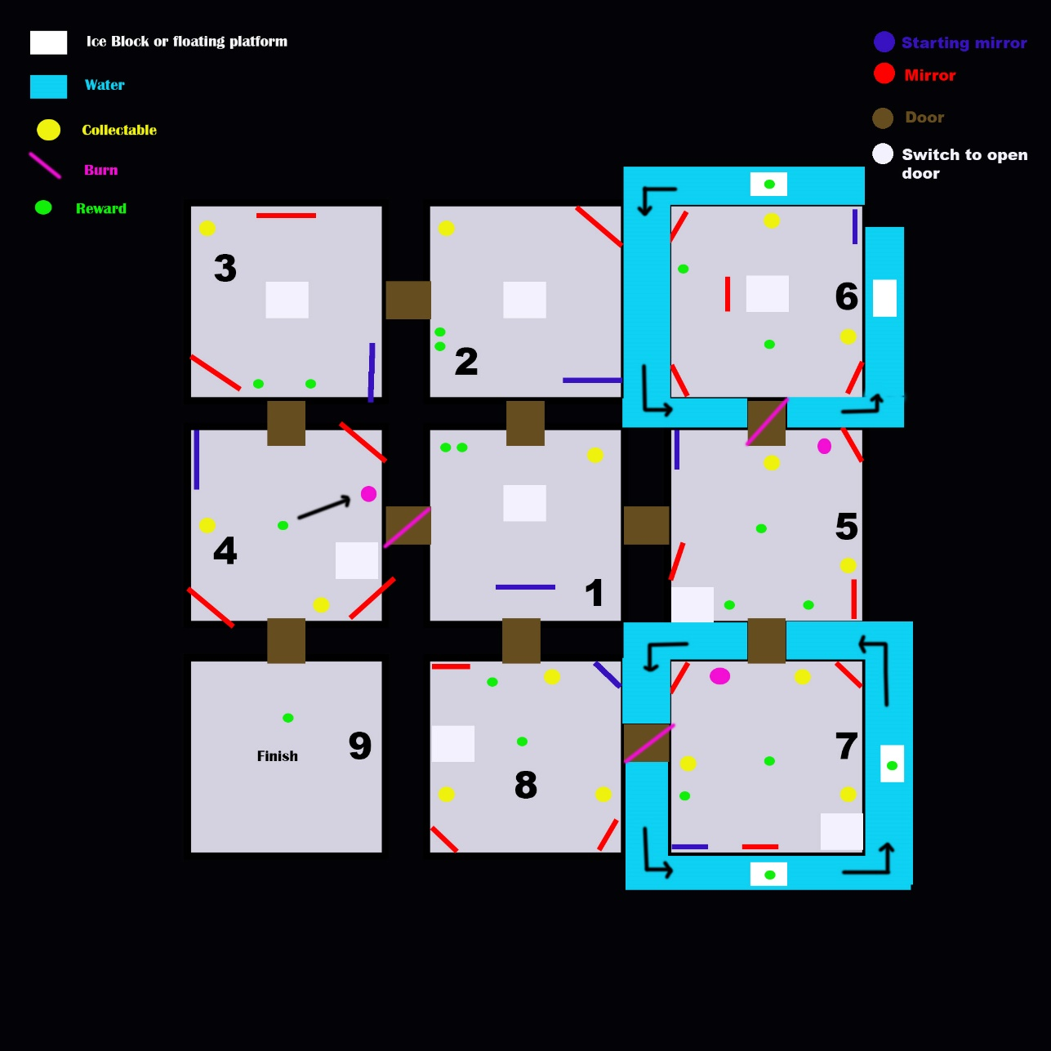

**Variable reward schedule -> size of reward / frequency of reward**

**Risk Reward -> risk of damage but defiantly get reward**

**Progression reward -> Need reward to process through level**

**Endowed Progress -> Giving players start of their collection at the start, increasing behaviour to continue to collect them.**

**Collectables (yellow) (Could be a key? Could be something else?)**

Collectables are used to gain access to the doors, there will be a counter UI to show how many collectables are in each room, so if they’re missing one they will explore until they have found it. For the learn stage of the learn, practise, master loop, they will be easily visible, and they will learn what they do. (act as a key / lock mechanic)

Need these to progress

Further in the levels, there are multiple. This will keep them in the room for longer as they need it to open the door.

Visual feedback -> 360 rotation? Light glow?

**Rewards (Green)**

Only spawn when puzzle is complete (like coins, maybe feathers or gems to say Hey! Well done?)

Visual feedback -> Heavy glow to show they’re important

There are 20 rewards that can be given to the player once they have completed a mirror puzzle. There will be another counter on the UI that will show for example 0/20.

There’s variability in the levels when it comes to rewards, each puzzle gives off a different amount.

These rewards act as an overall collection. The player doesn’t have to collect these rewards if they don’t want to, to progress through the game, but by using endowed progress at the start and giving them 6 rewards easily, their intrinsic motivation will kick in, and they will want to complete the collection. This is another way to keep them inside rooms, exploring them until they have found the remaining ones.

Room 4 the player will be introduced to the brazier when they have completed the puzzle. This will be given to the player as a half way reward. (A well done you’ve got this far, here have the ability to burn spider webs…. ) where it says / burn on the diagram, this is where the spider webs will be placed.

Moving platforms around room 6 and 7, is used to add risk reward. Once the puzzles are completed in these rooms, the rewards will be spread around the room. The platforms will move slowly (as we don’t want to punish the player for trying), they can walk onto these platforms when timed correctly, to receive their reward.

**Room one**

* Learn how the mirror puzzle works
* Collect Collectable to gain access to correct door 0/1 -> 1/1 -> room 2
* Gets rewarded 2 small rewards for completing the puzzle
* 0/20 -> 2/20 Rewards

**Room two**

* Interact with second mirror puzzle, 2 mirrors
* Collect collectable to gain access to correct door 0/1 -> 1/1 -> room 3
* Gets rewarded 2 small rewards for completing the puzzle
* 2/20 -> 4/20 Rewards

**Room three**

- Interact with third mirror puzzle, 3 mirrors

- Collect collectable to gain access to correct door 0/1 -> 1/1 -> room 4

- Gets rewarded 2 small rewards for completing the puzzle, spread out a bit this time.

- 4/20 -> 6/20 Rewards

**Room four**

* Interact with fourth mirror puzzle, 4 mirrors
* Collect two collectables to gain access to correct door 0/2 -2/2 -> room 5
* Player gets rewarded with a brazier, learning to burn spider webs on doors to walk through.
* 6/20 -> 7/20

**Room five**

* Interact with fifth mirror puzzle, 4 mirrors
* Collect two collectables to gain access to correct door 0/2 – 2/2 -> room 6
* Player gets rewarded with 3 small rewards, spread out across the room
* 7/20 -> 10/20
* Must burn spider web to go through door

**Room six**

* Interact with the sixth mirror puzzle, 5 mirrors
* Collect two collectables to gain access to correct door 0/2 – 2/2 ->room 7
* Player gets rewarded with 3 small rewards, they are spread out, one can be found on a moving platform (risk reward)
* 10/20 -> 13/20

**Room seven**

* Interact with seventh mirror puzzle, 4 mirrors
* Collect three collectables to gain access to correct door -> room 8
* Player gets rewarded with 4 small rewards, they are spread out widely. Two can be found on moving platforms (increase platform movement, making it faster)
* 13/20 -> 17/20
* Must burn spider web to proceed through the door

**Room eight**

* Interact with final mirror puzzle, 4 mirrors
* Collect three collectables to gain access to finish -> room 9!
* Player gets rewarded with 2 small rewards, they are spread out
* 17/20 -> 19/20

**Room nine**

Reward the player with a big reward (YAY YOU DID IT! Here have your final reward…..)

20/20

End game…..